Economic instruments for supplying agrobiodiversity conservation

**Warwick Wainwright**

Doctor of Philosophy – The University of Edinburgh – 2018

Declaration

I, Warwick Wainwright, declare that:

1. This thesis was composed by myself
2. The work contained herein is my own, except where clearly stated
3. The work has not been submitted for any other degree or professional qualification
4. Included publications are my own work

Signed: ____________________

Dated: _________________

Abstract

Graphical abstract

This should resemble the main finding from the thesis graphically. That is, incentives are needed to intervene to supply agrobiodiveristy optimally – i.e. the right locations, the right breeds / varieties / the right farmers / the right price. This requires targeting.

Good example figure here:

Esquinas-Alcázar, J., 2005. Protecting crop genetic diversity for food security: political, ethical and technical challenges. Nat. Rev. Genet. 6, 946–953.

Lay summary

Acknowledgements

I would like to express my thanks to my supervisors Professor Dominic Moran (SRUC) and Professor Geoff Simm (University of Edinburgh) for all their guidance and support.

Thanks also goes too Adam Drucker (Bioversity International), Alistair McVittie (SRUC), Bouda Ahmadi (SRUC), Faical Akaichi (SRUC), Klaus Glenk (SRUC), Libby Henson (Grassroots) and Tom Beeston (Rare Breeds Survival Trust), for their continued support and assistance with fieldwork.

I would also like to acknowledge funding for this PhD project provided by the Natural Environment Research Council (NERC) E3 Doctoral Training Programme (DTP). I also acknowledge funding from Operation Wallacea and the SADC Crop Wild Relatives Project (FED/2013/330-210) co-funded by the European Union and implemented through ACP-EU Co-operation Programme in Science and Technology. I also acknowledge the support of the Scottish Government’s Rural and Environment Science and Analytical Services Division (RESAS) funding to SRUC.

Finally, I wish to thank my family, Aaron, Hadley, Clive and Heather Wainwright for putting up with me.

Table of Contents

Economic instruments for supplying agrobiodiversity conservation 1

List of abbreviations 1

Author’s contribution to the field 1

Introduction 1

1.1 Global livestock production 1

1.2 What are Farm Animal Genetic Resources (FAnGR) 1

1.3 The importance of FAnGR 2

1.4 The state of FAnGR globally 3

1.5 Aims and objectives 3

1.6 Structure of the thesis 3

Valuing rare livestock breeds and farm animal genetic diversity: preferences, institutions and prospects 4

2.1 4

Contracts for supplying Farm Animal Genetic Resources (FAnGR) conservation services in Romania 4

Economic costs for in-situ conservation of Crop Wild Relatives (CWR) in Zambia: An application of Competitive Tender (CT) 5

Developing a prioritisation metric for conserving cattle native breeds at risk (NBAR) in the UK 5

Conclusion and recommendations 6

References 6

Appendix 6

List of abbreviations

Author’s contribution to the field

Chapter one

# Introduction

## Global agricultural production and food security

### Livestock production

The global livestock sector is estimated to account for 33% of agricultural Gross Domestic Product (GDP); employs 1.3 billion people and occupies some 30% of the planets ice-free surface (Steinfeld et al., 2007; Thornton, 2010). In developing countries, ~70% of the world’s rural poor rely on livestock for their livelihoods (Hiemstra et al., 2006). But livestock production’s environmental footprint is a cause for concern and has now come to the fore of global environmental governance and climate change discourse. Since 2000 it is estimated the livestock sector alone occupied 52% of humanity’s safe operating space for anthropogenic greenhouse gas (GHG) emissions (Pelletier and Tyedmers, 2010). At the same time, global production of meat is projected to more than double from 229 million tonnes in 1999/01 to 465 million tonnes in 2050 whilst milk production is expected to grow from 580 to 1,043 million tonnes (Steinfeld *et al.*, 2007). This shift from plant-based diets to more intensive demand for animal products has been coined the 'Livestock Revolution'(Delgado et al., 2001).

Rising consumption of livestock products is particularly evident in some, though not all, developing countries (Pica-Ciamarra and Otte, 2011) owing to growing populations, rising incomes and changing consumer preferences (Godfray et al., 2010). There is therefore a need to increase output to meet growing demand whilst simultaneously reducing the environmental impact per unit of livestock to avoid increasing environmental degradation (Pelletier and Tyedmers, 2010). This means increasing efficiencies per animal, whereby future livestock breeding programmes will arguably play a pivotal role. In this context, farm animal genetic resources (FAnGR) can make a significant contribution to improving the sustainability of livestock production (Eisler et al., 2014). Underpinning rapid growth of the livestock sector is global crop production.

### Crop production

Estimates suggest croplands cover some 12.6% of the earth’s ice-free land and account for 32% of all agricultural land (Foley et al., 2011; Latham et al., 2014). Some 36% of calories produced by the world’s food crops are used for animal feed and 4% for biofuel production (Cassidy et al., 2013). Today, just 12 plant species provide more than 70% of all human calorific food (Frison et al., 2012). The Food and Agriculture Organization (FAO) has estimated annual global production of crops will need to increase by 60% from 2006 levels to 2050 to keep pace with rising demand (FAO, 2016). However, potential yield gains are hindered by widespread land degradation, increasing water scarcity and climate change. A review of studies conducted for the Intergovernmental Panel on Climate Change (IPCC) suggests the latter will adversely affect crop yields post 2030 (Porter et al., 2014) and these impacts vary regionally (De Pinto et al., 2016). At the same time, the availability of viable crop land could be reduced by 8-20% by 2050 (Nellemann et al., 2009) and the nutritional quality of key food crops could decrease due to climate change (Myers et al., 2014).

Over the past 5 decades grain production has more than doubled, yet the amount of land devoted to arable production has increased by only 9% (Pretty, 2008). Advances in crop breeding, technological advancement and precision agriculture have all contribute to meeting growing demand. In the future, it is likely more food will need to be produced from similar, or shrinking, land availability (Godfray et al., 2010; Nellemann et al., 2009). To meet the Declaration of the World Summit on Food Security target of 70% more food by 2050, an average annual increase in crop production of 44 million metric tonnes is required, representing a 38% increase over historical increases in production (Tester and Langridge, 2010). Innovation to increase production is heavily reliant on crop breeding. But breeding goals do not solely relate to yield, and the importance of greater water- and nutrient-use efficiency, as well as tolerance to drought and salinity, is likely to increase (Tester and Langridge, 2010). The ability to grow crops in challenging environments, particularly those most affected by climate change, will require adaptive genetic resources. In this context, unexploited genetic material from land races and wild relatives will be important in allowing breeders to respond to new challenges (Maxted et al., 2011).

## The importance of agrobiodiveristy

### Overview

As previously noted, genetic resources and breeding advances are likely to play a crucial role in meeting future food security. These genetic resources come under the umbrella of ‘agrobiodiveristy’ – a debated notion generally referring to biodiversity for agriculture (Bàrberi, 2013). The FAO (1999) define it as “*The variety and variability of animals, plants and micro-organisms that are used directly or indirectly for food and agriculture, including crops, livestock, forestry and fisheries*”. This includes the diversity of genetic resources and species used for agri-production (i.e. breeds and varieties); non-harvested species that support food production systems (i.e. pollinators) and those in the wider environment that support agroecosystems (i.e. wild relatives) – see Figure x.

**Figure 1:** Venn diagram showing the subset of agrobiodiversity

Agrobiodiversity has arisen due to the interaction between the environment, genetic resources and management systems employed by culturally diverse groups. Such groups have shaped the wide ranging diversity encapsulated in global agri-systems, including plant and animal genetic resources (Zimmerer, 2014). The former components are the basis of this thesis but require further explanation.

### Farm Animal Genetic Resources (FAnGR)

FAnGR refers to the global pool of livestock diversity that has arisen through domestication and long-standing selective breeding (FAO, 2007). Most of the approximately 40 animal species relied upon worldwide today were domesticated around 10,000 to 12,000 years ago (Simm, 1998). Many of these species originated in areas of the world now occupied by developing countries (Figure x) and were subsequently transported globally following colonisation, human migration and trade (Hiemstra et al., 2006). Today, domestic animals supply around 30% of total human food requirements; whilst only 15 animal species worldwide account for 90% of livestock production globally (Villanueva et al., 2004).

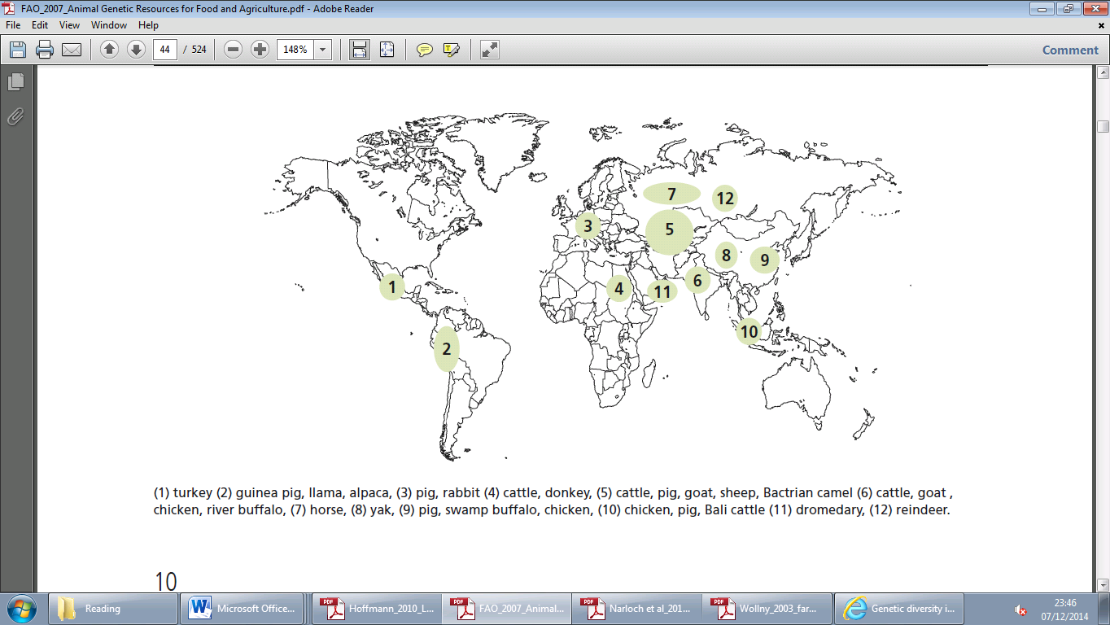

**Figure 2:** Major centres of livestock domestication (FAO, 2007)

Within species, selective breeding has resulted in high levels of breed diversity and it is estimated some 8,100 breeds[1] contribute to global livestock production (Yaro et al., 2017). Diversity within and between breeds is crucial to continue adapting and developing livestock production to meet rising global demand for meat, milk and eggs (DEFRA, 2013). However, livestock serve multiple direct and indirect uses beyond simply food production.

Directly, they are used for ploughing and transport, provide a local supply of manure and can be a vital source of income for rural communities (FAO, 2015a). Indirectly, diversity provides climate change resilience, risk mitigation (e.g. epidemics) and often reflect the important cultural heritage of communities (FAO, 2015b; Gandini et al., 2010; Springbett et al., 2003). Livestock diversity also provides a suit of additional ecosystem services not formerly mentioned (Hoffmann et al., 2014). A major argument for conservation of FAnGR is that breeds are central reservoirs of genetic variation which allow breeders to respond to new market signals or changing environmental conditions (Mathias and Mundy, 2010 ; Pouta, 2011). It would be difficult and costly to reinstate this genetic variation (Stoneham et al., 2010).

### Plant Genetic Resources (PGR)

PGR includes both traditional farmers’ varieties and the wild relatives of cultivated plants (FAO, 2010). Both have been used extensively in crop improvement and to great effect (Esquinas-Alcázar, 2005). PGR diversity directly contributes to increasing food security and resilience, enhancing nutritional qualities of cultivators and reducing susceptibility of crops to drought, pests and disease (Frison et al., 2011; Rubenstein et al., 2011). Indirectly, PGR improve rural livelihoods, support the maintenance of ecosystem services including cultural values and provide adaptation to climate change (Jarvis et al., 2015; Sthapit et al., 2008). The global benefits of yield increases from genetic improvements to date range from US$ 8 to 15 billion (Frisvold et al., 2003).

Today, the genetic uniformity of many modern crop varieties has raised concerns that crop yields and production will become more vulnerable to evolving pests and diseases (Rubenstein et al., 2011). But with improved technological capabilities, these resources are becoming easier to monitor, characterise and utilise (Frison and Demers, 2014). Countries are now gaining new insights into the benefits of ensuing greater diversity as a response to growing homogenisation that reduces adaptability and increases risk. In this context, ‘temporal diversity’, changing varieties more frequently to maintain resistance to pests and diseases, is increasingly employed (Rubenstein et al., 2011).

Public sector plant breeding has been continually contracting, whilst the private sector becomes increasingly dominant in the research and development of new varieties. This is equally true for FAnGR and has implications for the management and use of animal and plant genetic resources, not least in terms of how suppliers of diversity should be recognised and how beneficiaries engage with them. It is therefore of interest to assess the state of both facets of diversity – including threats and conservation initiatives.

## The state of PGR and FAnGR globally

### Threats and pressures

The importance of improving breed and crop varieties to increase production is vital. But current techniques employed to do so risk losing diversity with potentially severe consequences for agricultural production. Work on farm animals suggests diversity within breeds is declining (Groeneveld et al., 2010), though these findings cannot be extrapolated to crop varieties (van de Wouw et al., 2010). Nevertheless, it is evident we now rely on fewer breeds and varieties for the majority of production than ever before. Declining diversity across both PGR and FAnGR is generally borne from similar proximate threats including habitat loss, globalisation, overexploitation, political instability and intensification (FAO, 2010; Hoffmann, 2011; Yaro et al., 2017). Causative drivers of diversity loss stem from indiscriminate cross-breeding; conversion to high yielding breeds and varieties; climate change and disease epidemics (Castañeda-Álvarez et al., 2016; Sharma and Ahlawat, 2017).

In addition, the global distribution of plant and animal genetic resources is heterogeneous. Plant genetic resources, mainly through crop wild relatives (CWR), tend to be concentred around eight ‘vavilov’ centres[2] that tend to follow the equator (Maxted and Kell, 2009). The severity of threats posed to genetic resources varies across these centres. Similarly, the global distribution of livestock breeds and proportion of at-risk breeds is also heterogeneously distributed (Figure x). Some 70% of livestock breeds are said to be located in developing countries (Villanueva et al., 2004). These factors, combined with proximate and direct pressures, influence how we should respond to ameliorate diversity loss through two main conservation responses – *ex-situ* and *in-situ*.

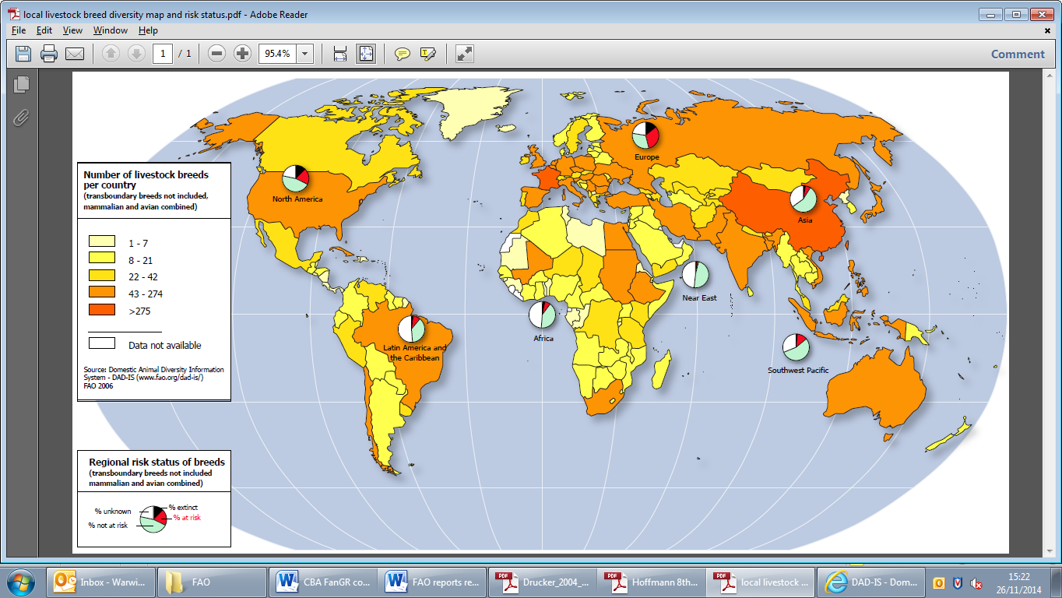

**Figure 4:** Distribution of the world’s livestock breeds and regional risk status of breeds (FAO, 2007)

### Ex-situ conservation

*Ex-situ* conservation generally refers to the preservation of breeds/varieties outside their natural environment. Most notably, but not exclusively, is conservation in genebanks – the collections of germplasm that are cryogenically frozen. Germplasm refers to genetic material useful for animal and plant breeding and most prominently includes semen, embryos, DNA, seeds and pollen.

Genebanks, for both PGR and FAnGR are advantageous as they offer protection from disease epidemics and natural catastrophes (Boettcher, 2012). In addition, ex-situ offers economy of space, relatively low labour demands and, consequently, the capacity to maintain large samples at lower cost than *in-situ* approaches (Rajasekharan, 2015). But a major disadvantage is that the genetic material is unable to adapt and evolve over time (DEFRA, 2006). In addition, only a small amount of the genetic diversity present in a given population is usually represented in the collection (Esquinas-Alcázar, 2005). *Ex-situ* also negates the cultural and heritage value attributes of conservation cannot be realised.

Many accessions, of both plants and animals, are also inadvertently duplicated – resulting in unwanted overlap and costly redundancies (ref). There is therefore a strong case for greater rationalisation of collections through optimisation modelling, whereby maximal diversity is conserved for minimum cost. Additionally, *ex-situ* approaches are also limited by technological progress in genetic techniques to cryogenically freeze material. This is particularly evident in FAnGR, where the freezing of certain types of genetic material for some species is still not possible (ref). Thus, while *ex-situ* offers some benefits, it cannot supply all conservation needs or values. It is therefore often thought of as complimentary to *in-situ* approaches (ref).

From Rajasekharan (2015)

There are about six million accessions, or samples of a

particular population, stored as seeds in about 1,300 gene banks throughout

the world as of 2006. Just under half of the six million accessions are

held in 12 national collections

Seed banking has considerable advantages over other methods

of *ex situ* conservation such as ease of storage, economy of space, relatively

low labour demands and, consequently, the capacity to maintain

large samples at an economically viable cost.

The annual cost (in year 2000 US$) of conserving

and distributing the genetic material presently

held in all 11 CGIAR gene banks is

estimated to be 5.7 million US$ (m US$), which

could be maintained for all future generations by

setting aside a fund of 149 m US$ (invested at a

real rate of interest of 4 % per annum) (Virchow

2003 ).

However, the costs associated with ex-situ storage remain poorly understood (FAO, 2015). Semen from most livestock species can be frozen but with varying results (FAO, 2012).

The below is from Alcazar et al (2005)

*Ex situ* conservation in gene banks

is mainly used for cultivated plants that

are propagated through seeds. This tends

to be cheaper than *in situ* conservation,

requires little space and resources are

easily accessible to plant breeders6–8. The

main drawback, however, is that a genetic

resource ceases to evolve as the natural

processes of selection and adaptation are

halted

. In addition, only a small amount

of the genetic diversity present in a given

population is usually represented in the

collected sample. This is further reduced

every time the resource is regenerated,

owing to genetic drift and natural selective

pressures under different environmental

conditions. Furthermore, many gene

banks do not meet appropriate standards

of storage and regeneration, resulting in

poor seed viability3,9–12.

Nevertheless, *ex situ* collections have a

crucial role in the conservation of many

varieties, particularly those that have already

disappeared from the field. However, many

accessions are inadvertently duplicated12,13

and minor crops and wild relatives of crops

are poorly represented14,15.

The total number of accessions conserved *ex situ* worldwide has increased by approximately

20 percent since 1996, reaching 7.4 million. While new collecting accounted for at least

240 000 accessions, and possibly considerably more, much of the overall increase is the

result of exchange and unplanned duplication. It is estimated that less than 30 percent

of the total number of accessions are distinct. There is still a need for greater rationalization among collections globally. For several staple crops, such as wheat and

rice, a large part of the genetic diversity is currently represented in collections. However, for

many others, considerable gaps remain. Interest in collecting CWR, landraces and neglected

and underutilized species, is growing as land-use systems change and environmental

concerns increase the likelihood of their erosion.

### In-situ conservation

*In situ* conservation involves the protection of the areas, ecosystems and habitats in which plants and animals of interest have developed their distinctive characteristics. This includes maintenance of the (often extensive) production systems that support various breeds and cultivars of interest.

The main advantage of *in-situ* approaches is that the evolutionary dynamics of the breed or variety is maintained – thus enabling the continued adaption of genetic material. In addition, the resource can be harvested and the cultural or heritage value of the breed/variety can be enjoyed.

he great advantage is that

the evolutionary dynamics of the species are

maintained. The principal drawbacks are the

costs that are associated with incentives and

law enforcement, and the social and political

difficulties that occasionally arise, especially

for on-farm management. This method

might be economical, however, if the aim is

to conserve all species within a specific area,

rather than just one18–24.

Conservation is generally achieved through legislative measures and the use of incentives that provide producers or land managers with a reward for conservation effort (Narloch et al., 2011).

The below is from Alcazar et al (2005)

*In situ* conservation involves the protection

of the areas, ecosystems and habitats in

which plants of interest have developed their

distinctive characteristics, and is achieved

through legislative measures and the use of

incentives. This is the preferred technique

for wild plants; the great advantage is that

the evolutionary dynamics of the species are

maintained. The principal drawbacks are the

costs that are associated with incentives and

law enforcement, and the social and political

difficulties that occasionally arise, especially

for on-farm management. This method

might be economical, however, if the aim is

to conserve all species within a specific area,

rather than just one18–24.

An increasing number of *in situ* conservation

areas, including conservation on-farm in

traditional agricultural systems, are protected

at the national level3, but conservation areas

that are specific to PGRFA are still rare14,25.

## Economic incentives for conservation

Rubenstein et al 2011:

the use of genetic resources by one farmer or plant breeder does not preclude their use by another, so private incentives to sustain diverse genetic resources are low. This motivates public measures (and underlying research) to conserve genetic resources.

At the same time, genetic resource conservation is expensive, and

both private incentives and public funding are limited.

Previous work has found private incentives for conservation are likely not sufficient to achieve a level of crop genetic diversity that is socially optimal.

## Aims and objectives

## Structure of the thesis

# Valuing rare livestock breeds and farm animal genetic diversity: preferences, institutions and prospects

The chapter focuses on the distinction between ‘rare breeds’ and FAnGR more generally. Highlighting the links between FAnGR and the sustainable intensification (SI) agenda, we discuss the prioritisation of efficiency objectives in the food system (and associated supply chains) over culture and heritage values. Drawing on the latter, we link this example to the case of rare breeds which often possess attributes of value not linked to production efficiency. The chapter concludes with wider discussion concerning three potential threats to rare breeds; SI, climate change and disease events. But opportunities for rare breeds, in the form of new production and market opportunities, are also discussed in the form of these three issues.

Chapter type: Review chapter

Completeness: 90%

Expected completion date: June 2017

# Contracts for supplying Farm Animal Genetic Resources (FAnGR) conservation services in Romania

The chapter explores the barriers to participate in rare breed conservation programmes for farmers in small scale systems in Romania. We use a choice experiment (CE) to determine attributes of a conservation contract that may be less or more desirable from a farmer perspective whilst also measuring WTA conservation subsides. The former are used to inform the design of contracts whilst the latter are contrasted with subsidy payment rates (Euro/head livestock/year) proposed by the EU for keeping rare breeds. We outline the probability of contractual enrolment among different farmer groups and suggest options for improving farmer uptake. The chapter discusses the importance of embedding FAnGR conservation in other policy measures linked to wider rural development policy, such as those targeting preservation of traditional agricultural systems.

Chapter type: Empirical work

Completeness: 80%

Expected completion date: Sept 2017

# Economic costs for in-situ conservation of Crop Wild Relatives (CWR) in Zambia: An application of Competitive Tender (CT)

The chapter identifies the lack of robust economic estimates concerning the costs surrounding in-situ CWR conservation. We discuss the cost implications of using different Area management options (AMOs) for conservation services and how the ‘mix’ of these might lead to fundamentally different conservation outcomes (i.e. species and diversity) and costs. The article moves to discuss the resource requirements should a national *in-situ* CWR conservation strategy be implemented in Zambia. The article concludes with a summary of wider deliberation concerning the use of PES including equitability and cost effectiveness considerations.

Chapter type: Empirical work

Completeness: 60%

Expected completion date: November 2017

# Developing a prioritisation metric for conserving cattle native breeds at risk (NBAR) in the UK

Prioritisation measures and indicators currently developed to inform FAnGR conservation planning are too data intensive and specific. Consequently, there has been low/no uptake of these indicators by governments or NGO’s to inform their conservation efforts. Using multi-criteria decision analysis (MCDA) we hope to demonstrate the benefits of developing more comprehensive policy support tools to improve genetic resources conservation, using UK cattle NBAR as a case study. The MCDA will consider a set of holistic criteria including diversity, utility and endangerment to inform decision making and the use of incentives to support NBAR. The chapter will discuss some concerns raised by participants to a recent workshop, organised by SRUC, discussing the use of indicators for NBAR conservation. These concerns explicitly related to how such metrics might be used, the potential for misuse and the need for improved communication between NBAR stakeholders and government.

Chapter type: Methodological contribution

Completeness: 30%

Expected completion date: February 2018(Hoyos, 2010)

# Conclusion and recommendations

## Conclusions

## Recommendations

## Further work

## Challenges for the future

# References

# Appendix

1. Note, the definition of a breed is contested, but in its simplest terms it refers to a recognised group of interbreeding animals of a given species, usually of fairly uniform appearance (Rajasekharan, 2015)
2. Vavilov centres are centres of origin/diversity for cultivated plants